Experiment 06
Name : Iqra Shaikh
Rollno: 24DCO06

AIM: WAP To perform socket programming .

Network programming in Java enables communication between multiple devices connected via a network. It relies on sockets, which act as endpoints combining an IP address and port number to establish reliable communication channels. Using the java.net package, applications can implement both server and client programs to exchange data efficiently.

A server uses ServerSocket to listen on a specific port, while the client uses Socket to connect. Once connected, data transfer occurs through input and output streams. TCP ensures reliable, two-way communication, while UDP supports faster but connectionless communication. This makes sockets a fundamental concept in building network-based applications.

Sever.java
import java.io.*;
import java.net.*;
import java.util.Scanner;
class server
{
public static void main(String [] args) throws IOException
{
int number;
ServerSocket s=new ServerSocket(1654);
Socket so=s.accept();
Scanner sc=new Scanner(so.getInputStream());
int n=sc.nextInt();
int m=sc.nextInt();
int area=m*n;
PrintStream p=new PrintStream(so.getOutputStream());
System.out.println("Area calc here is "+area);
p.println(area);
}
}

Client.java
import java.io.*;
import java.net.*;
import java.util.Scanner;
class client
{
public static void main(String [] args) throws IOException
{
int number;
Scanner sc=new Scanner(System.in);
int l=sc.nextInt();
int b=sc.nextInt();
Socket s=new Socket("127.0.0.1",1654);
PrintStream p=new PrintStream(s.getOutputStream());
p.println(l);
p.println(b);
Scanner sc1=new Scanner(s.getInputStream());
int area=sc1.nextInt();
System.out.println("Area is "+area);
}
}

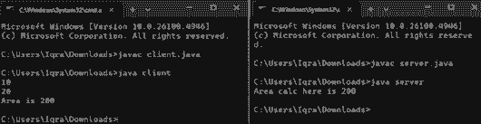

Conclusion:
In conclusion, Java socket programming provides a simple and effective way to enable communication between systems over a network. By using sockets with TCP or UDP, developers can build reliable, real-time client-server applications.

